Forms Designed in HOTEL MANAGEMENT

Login Form

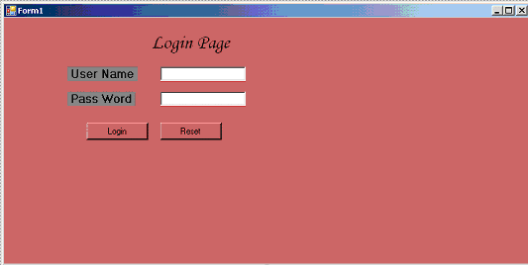

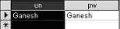

Dim un, pw As String

Private Sub cmdlogin_Click(ByVal sender As Object, ByVal e As System.EventArgs) Handles cmdlogin.Click
Dim str1 As String
Dim str As String
str = "Provider=Microsoft.JET.OLEDB.4.0;Data Source=D:\sunil\hotel1.mdb;"
Dim con As New OleDbConnection(str)
con.Open()
str1 = "Select * from Login"
Dim cmd As New System.Data.OleDb.OleDbCommand(str1, con)
Dim adp As New System.Data.OleDb.OleDbDataAdapter(cmd)
Dim ds As New DataSet
Dim dt As New DataTable
adp.Fill(ds, "Login")
dt = ds.Tables("Login")
un = Trim(ds.Tables("Login").Rows(0).Item("un"))
pw = Trim(ds.Tables("Login").Rows(0).Item("pw"))
con.Close()
If txtun.Text = un And txtpwd.Text = pw Then
Dim f2 As New Form2
f2.Show()
Me.Hide()
Else
MsgBox("Login is Not Possible")
End If
End Sub

Form2

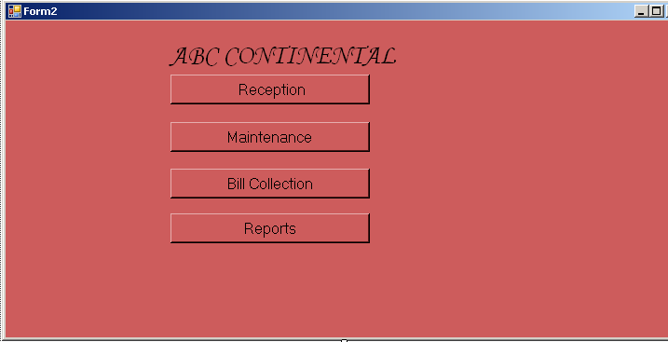

Code of Form2

Private Sub cmdRec_Click(ByVal sender As System.Object, ByVal e As System.EventArgs) Handles cmdRec.Click
Dim f3 As New Form3
f3.Show()
Me.Hide()
End Sub
Private Sub cmdMan_Click(ByVal sender As System.Object, ByVal e As System.EventArgs) Handles cmdMan.Click
Dim f4 As New Form4
f4.Show()
End Sub
Private Sub cmdBills_Click(ByVal sender As System.Object, ByVal e As System.EventArgs) Handles cmdBills.Click
Dim f6 As New Form6
f6.Show()
End Sub
Private Sub Button1_Click(ByVal sender As System.Object, ByVal e As System.EventArgs) Handles Button1.Click
Dim f12 As New Form12
f12.Show()
Me.Hide()
End Sub

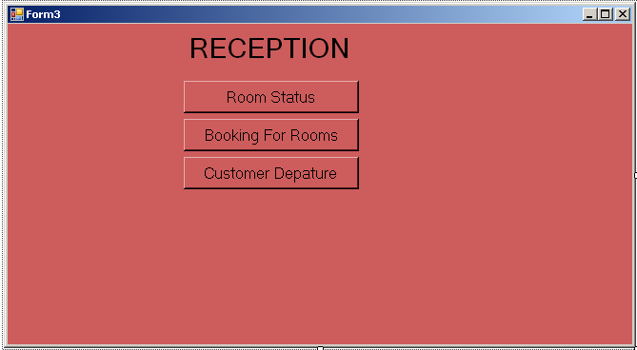

Form3 Code

Private Sub cmdMRM_Click(ByVal sender As System.Object, ByVal e As System.EventArgs) Handles cmdMRM.Click
Dim f9 As New Form9
f9.Show()
Me.Hide()
End Sub

Private Sub Button1_Click(ByVal sender As System.Object, ByVal e As System.EventArgs) Handles Button1.Click
Dim f7 As New Form7
f7.Show()
Me.Hide()
End Sub

Private Sub Button2_Click(ByVal sender As System.Object, ByVal e As System.EventArgs) Handles Button2.Click
Dim f14 As New Form14
f14.Show()
End Sub

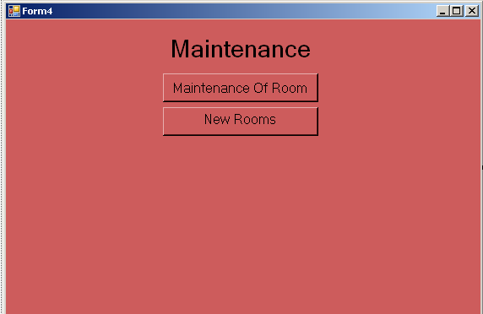

Form3 Code
Private Sub cmdMRM_Click(ByVal sender As System.Object, ByVal e As System.EventArgs) Handles cmdMRM.Click
Dim f5 As New Form5
f5.Show()
Me.Hide()
End Sub

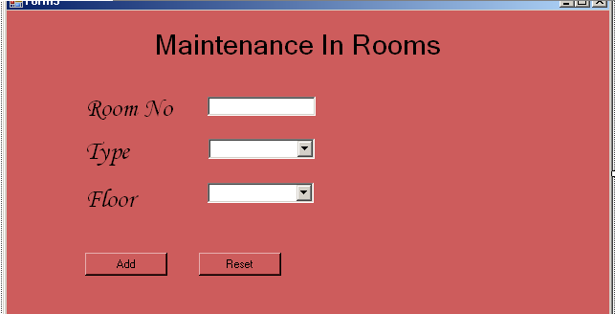

Maintenance Form Code

Imports System.Data.OleDb
Public Class Form5

Private Sub cmdAdd_Click(ByVal sender As System.Object, ByVal e As System.EventArgs) Handles cmdAdd.Click
Dim str As String
str = "Provider=Microsoft.JET.OLEDB.4.0;Data Source=D:\sunil\hotel1.mdb;"
Dim con As New OleDbConnection(str)
Dim str2 As String
con.Open()
str2 = "Insert into Main values("
str2 = str2 & Val(TextBox1.Text) & ",'"
str2 = str2 & ComTyp.Text & "',"
str2 = str2 & Val(ComFloor.Text) & ")"
Dim cmd As New OleDbCommand(str2, con)
cmd.ExecuteNonQuery()
cmd.CommandText = str2
MsgBox("Record Inserted")
con.Close()
End Sub
Maintaence Table

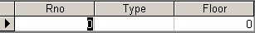

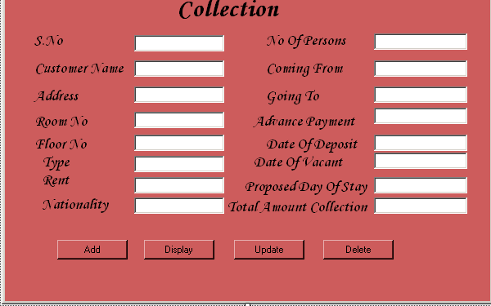
Collection Form Details and Code

Imports System.Data.OleDb
Public Class Form6
Dim tot As Long
Dim z As Long
Private Sub cmdAdd_Click(ByVal sender As System.Object, ByVal e As System.EventArgs) Handles cmdAdd.Click
Dim str As String
str = "Provider=Microsoft.JET.OLEDB.4.0;Data Source=D:\sunil\hotel1.mdb;"
Dim con1 As New OleDbConnection(str)
con1.Open()
Dim str2 As String
str2 = "insert into coll values("
str2 = str2 & Val(TextBox1.Text) & ",'"
str2 = str2 & TextBox2.Text & " ','"
str2 = str2 & TextBox3.Text & "',"
str2 = str2 & Val(TextBox4.Text) & ","
str2 = str2 & Val(TextBox5.Text) & ",'"
str2 = str2 & TextBox6.Text & "',"
str2 = str2 & Val(TextBox7.Text) & ",'"
str2 = str2 & TextBox8.Text & "',"
str2 = str2 & Val(TextBox16.Text) & ",'"
str2 = str2 & TextBox15.Text & "','"
str2 = str2 & TextBox14.Text & "',"
str2 = str2 & Val(TextBox12.Text) & ",'"
str2 = str2 & TextBox11.Text & "','"
str2 = str2 & TextBox10.Text & "',"
str2 = str2 & Val(TextBox13.Text) & ","
str2 = str2 & Val(TextBox9.Text) & ")"
Dim cmd As New OleDbCommand(str2, con1)
cmd.ExecuteNonQuery()
MsgBox("Record inserted")
End Sub

Private Sub TextBox1_Leave(ByVal sender As Object, ByVal e As System.EventArgs) Handles TextBox1.Leave
Dim str As String
str = "Provider=Microsoft.JET.OLEDB.4.0;Data Source=D:\sunil\hotel1.mdb;"
Dim con As New OleDbConnection(str)
con.Open()
Dim str2 As String
str2 = "select * from book where Sno=" & Val(TextBox1.Text)
Dim cmd As New OleDbCommand(str2, con)
Dim adp As New OleDbDataAdapter(cmd)
Dim ds As New DataSet
Dim dt As New DataTable
adp.Fill(ds, "book")
dt = ds.Tables("book")
TextBox2.Text = ds.Tables("book").Rows(0).Item("Cname")
TextBox3.Text = ds.Tables("book").Rows(0).Item("Add")
TextBox4.Text = ds.Tables("book").Rows(0).Item("Floor")
TextBox5.Text = ds.Tables("book").Rows(0).Item("Rno")
TextBox6.Text = ds.Tables("book").Rows(0).Item("Type")
TextBox7.Text = ds.Tables("book").Rows(0).Item("Rent")
TextBox8.Text = ds.Tables("book").Rows(0).Item("Nationality")
TextBox16.Text = ds.Tables("book").Rows(0).Item("Nop")
TextBox15.Text = ds.Tables("book").Rows(0).Item("Coming")
TextBox14.Text = ds.Tables("book").Rows(0).Item("Going")
TextBox12.Text = ds.Tables("book").Rows(0).Item("Apay")
TextBox11.Text = ds.Tables("book").Rows(0).Item("Dob")
End Sub

Private Sub TextBox9_Enter(ByVal sender As Object, ByVal e As System.EventArgs) Handles TextBox9.Enter
tot = Val(TextBox13.Text) * Val(TextBox7.Text)
TextBox9.Text = tot - Val(TextBox12.Text)
End Sub

Private Sub TextBox10_Leave(ByVal sender As System.Object, ByVal e As System.EventArgs) Handles TextBox10.Leave
Dim str, st As String
st = "Vacant"
str = "Provider=Microsoft.JET.OLEDB.4.0;Data Source=D:\sunil\hotel1.mdb;"
Dim con2 As New OleDbConnection(str)
Dim str2 As String
con2.Open()
str2 = "update rms set status='" & st & "' where sno=" & Val(TextBox1.Text)
Dim cmd2 As New OleDbCommand(str2, con2)
cmd2.ExecuteNonQuery()
MsgBox("Record Updated")
End Sub

Private Sub TextBox13_Enter(ByVal sender As Object, ByVal e As System.EventArgs) Handles TextBox13.Enter
Dim dt1, dt2 As String
dt1 = TextBox10.Text.ToString()
dt2 = TextBox11.Text.ToString()
' Declare variables.
Dim SecondDate As Date
Dim thirddate As Date
SecondDate = CDate(dt1)
thirddate = CDate(dt2)
Dim x As Long = DateDiff(DateInterval.Day, Now, SecondDate)
Dim y As Long = DateDiff(DateInterval.Day, Now, thirddate)
z = x - y
MessageBox.Show(z, "due days", MessageBoxButtons.OK)
TextBox13.Text = z
End Sub

Private Sub Button1_Click(ByVal sender As System.Object, ByVal e As System.EventArgs) Handles Button1.Click
Dim str As String
str = "Provider=Microsoft.JET.OLEDB.4.0;Data Source=D:\sunil\hotel1.mdb;"
Dim con As New OleDbConnection(str)
Dim sel As String
sel = "select * from coll where Sno=" & Val(TextBox1.Text)
Dim com As New OleDbCommand(sel, con)
Dim adp As New OleDbDataAdapter(com)
Dim ds As New DataSet
Dim dt As New DataTable
adp.Fill(ds, "coll")
dt = ds.Tables("coll")
TextBox2.Text = ds.Tables("coll").Rows(0).Item("Cname")
TextBox3.Text = ds.Tables("coll").Rows(0).Item("Add")
TextBox4.Text = ds.Tables("coll").Rows(0).Item("Rno")
TextBox5.Text = ds.Tables("coll").Rows(0).Item("Flr")
TextBox6.Text = ds.Tables("coll").Rows(0).Item("Type")
TextBox7.Text = ds.Tables("coll").Rows(0).Item("Rent")
TextBox8.Text = ds.Tables("coll").Rows(0).Item("Nat")
TextBox16.Text = ds.Tables("coll").Rows(0).Item("Nop")
TextBox15.Text = ds.Tables("coll").Rows(0).Item("Com")
TextBox14.Text = ds.Tables("coll").Rows(0).Item("Gon")
TextBox12.Text = ds.Tables("coll").Rows(0).Item("Adp")
TextBox11.Text = ds.Tables("coll").Rows(0).Item("Dod")
TextBox10.Text = ds.Tables("coll").Rows(0).Item("Dov")
TextBox13.Text = ds.Tables("coll").Rows(0).Item("Pnop")
TextBox9.Text = ds.Tables("coll").Rows(0).Item("Tamt")
con.Close()
End Sub

Private Sub Button2_Click(ByVal sender As System.Object, ByVal e As System.EventArgs) Handles Button2.Click
'Dim str As String
'str = "Provider=Microsoft.JET.OLEDB.4.0;Data Source=D:\sunil\hotel1.mdb;"
'Dim con As New OleDbConnection(str)
'Dim upt As String
'upt = "update coll set Cname='" & TextBox2.Text & "',Add='" & TextBox3.Text & "',Rno=" & Val(TextBox4.Text) & ",Flr=" & Val(TextBox5.Text) & ",Type='" & TextBox6.Text & "',Rent=" & Val(TextBox7.Text) & ",Nat='" & TextBox8.Text & "',Nop=" & Val(TextBox16.Text) & ",Com='" & TextBox15.Text & "',Gon='" & TextBox14.Text & "',Adp=" & Val(TextBox12.Text) & ",Dod='" & TextBox11.Text & "',Dov='"

End Sub

Private Sub TextBox9_TextChanged(ByVal sender As System.Object, ByVal e As System.EventArgs) Handles TextBox9.TextChanged

End Sub
End Class

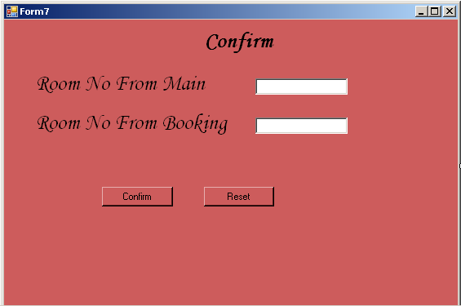

Room Confirmation Form Details and Code

Imports System.Data.OleDb

Public Class Form7

Private Sub TextBox1_Leave(ByVal sender As Object, ByVal e As System.EventArgs) Handles TextBox1.Leave
Dim str As String
str = "Provider=Microsoft.JET.OLEDB.4.0;Data Source=D:\sunil\hotel1.mdb;"
Dim con As New OleDbConnection(str)
Dim str1 As String
con.Open()
str1 = "select * from Main where Rno=" & Val(TextBox1.Text)
Dim cmd As New OleDbCommand(str1, con)
'Dim asp As New OleDbDataAdapter(cmd)
'Dim ds As New DataSet
'Dim dt As New DataTable
'asp.Fill(ds, "Main")
'dt = ds.Tables("Main")
con.Close()
End Sub
Private Sub TextBox2_Leave(ByVal sender As Object, ByVal e As System.EventArgs) Handles TextBox2.Leave
Dim str As String
str = "Provider=Microsoft.JET.OLEDB.4.0;Data Source=D:\sunil\hotel1.mdb;"
Dim con1 As New OleDbConnection(str)
con1.Open()
Dim str2 As String
str2 = "select * from book where Rno=" & TextBox2.Text
Dim cmd As New OleDbCommand(str2, con1)
'Dim asp As New OleDbDataAdapter(cmd)
'Dim ds As New DataSet
'Dim dt As New DataTable
'asp.Fill(ds, "book")
'dt = ds.Tables("book")
con1.Close()
End Sub

Private Sub Button2_Click(ByVal sender As System.Object, ByVal e As System.EventArgs) Handles Button2.Click
If TextBox1.Text = TextBox2.Text Then
MsgBox("Booking is not possible")
Else
Dim f8 As New Form8
f8.Show()
Me.Hide()
End If
End Sub
End Class

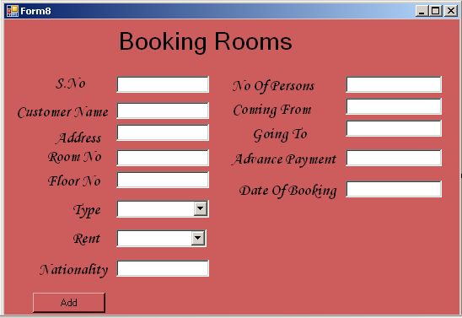
Booking Rooms Form and Code

Imports System.Data.OleDb
Public Class Form8
Private Sub cmdAdd_Click(ByVal sender As System.Object, ByVal e As System.EventArgs) Handles cmdAdd.Click
Dim str As String
str = "Provider=Microsoft.JET.OLEDB.4.0;Data Source=D:\sunil\hotel1.mdb;"
Dim con1 As New OleDbConnection(str)
con1.Open()
Dim str2 As String
str2 = "insert into book values("
str2 = str2 & Val(TextBox1.Text) & ",'"
str2 = str2 & TextBox2.Text & " ','"
str2 = str2 & TextBox3.Text & "',"
str2 = str2 & Val(TextBox4.Text) & ","
str2 = str2 & Val(TextBox5.Text) & ",'"
str2 = str2 & ComboBox1.Text & "',"
str2 = str2 & Val(ComboBox2.Text) & ",'"
str2 = str2 & TextBox8.Text & "',"
str2 = str2 & Val(TextBox16.Text) & ",'"
str2 = str2 & TextBox15.Text & "','"
str2 = str2 & TextBox14.Text & "',"
str2 = str2 & Val(TextBox12.Text) & ",'"
str2 = str2 & TextBox6.Text & "')"
Dim cmd As New OleDbCommand(str2, con1)
cmd.ExecuteNonQuery()
MsgBox("Record inserted")
con1.Close()
End Sub

Private Sub TextBox6_Leave(ByVal sender As Object, ByVal e As System.EventArgs) Handles TextBox6.Leave
Dim str, sta As String
sta = "Not Vaccant"
str = "Provider=Microsoft.JET.OLEDB.4.0;Data Source=D:\sunil\hotel1.mdb;"
Dim con As New OleDbConnection(str)
Dim str2 As String
con.Open()
str2 = "insert into rms values("
str2 = str2 & Val(TextBox1.Text) & ","
str2 = str2 & Val(TextBox4.Text) & ","
str2 = str2 & Val(TextBox5.Text) & ",'"
str2 = str2 & ComboBox1.Text & "',"
str2 = str2 & Val(ComboBox2.Text) & ",'"
str2 = str2 & sta & "','"
str2 = str2 & TextBox2.Text & "','"
str2 = str2 & TextBox3.Text & "','"
str2 = str2 & TextBox6.Text & "')"
Dim com As New OleDbCommand(str2, con)
com.ExecuteNonQuery()
MsgBox("Record Inserted")
con.Close()
End Sub

Private Sub Button1_Click(ByVal sender As System.Object, ByVal e As System.EventArgs) Handles Button1.Click
Dim f2 As New Form2
f2.Show()
Me.Hide()
End Sub
End Class
Booking Table

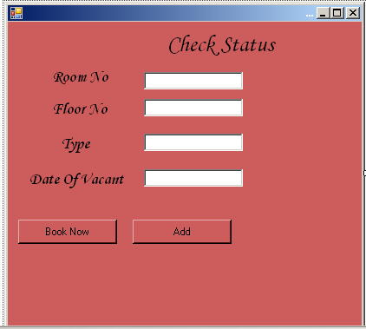

Check Status and Code

Imports System.Data.OleDb
Public Class Form9

Private Sub TextBox1_Leave(ByVal sender As System.Object, ByVal e As System.EventArgs) Handles TextBox1.Leave
Dim str As String
str = "Provider=Microsoft.JET.OLEDB.4.0;Data Source=D:\sunil\hotel1.mdb;"
Dim con1 As New OleDbConnection(str)
Dim str1 As String
str1 = "select Flr,Type,Dov from coll where Rno=" & Val(TextBox1.Text)
Dim cmd As New OleDbCommand(str1, con1)
Dim adp As New OleDbDataAdapter(cmd)
Dim ds As New DataSet
Dim dt As New DataTable
adp.Fill(ds, "coll")
dt = ds.Tables("coll")
TextBox2.Text = ds.Tables("coll").Rows(0).Item("Flr")
TextBox3.Text = ds.Tables("coll").Rows(0).Item("Type")
TextBox4.Text = ds.Tables("coll").Rows(0).Item("Dov")
con1.Close()
End Sub
Private Sub Button1_Click(ByVal sender As System.Object, ByVal e As System.EventArgs) Handles Button1.Click
Dim f3 As New Form3
f3.Show()
End Sub

Private Sub Button2_Click(ByVal sender As System.Object, ByVal e As System.EventArgs) Handles Button2.Click
Dim str As String
str = "Provider=Microsoft.JET.OLEDB.4.0;Data Source=D:\sunil\hotel1.mdb;"
Dim con1 As New OleDbConnection(str)
con1.Open()
Dim str2 As String
str2 = "insert into Cks values("
str2 = str2 & Val(TextBox1.Text) & ","
str2 = str2 & Val(TextBox2.Text) & ",'"
str2 = str2 & TextBox3.Text & "','"
str2 = str2 & TextBox4.Text & "')"
Dim cmd As New OleDbCommand(str2, con1)
cmd.ExecuteNonQuery()
MsgBox("Record Inserted")
con1.Close()
End Sub
End Class

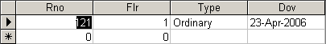

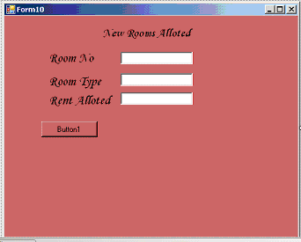

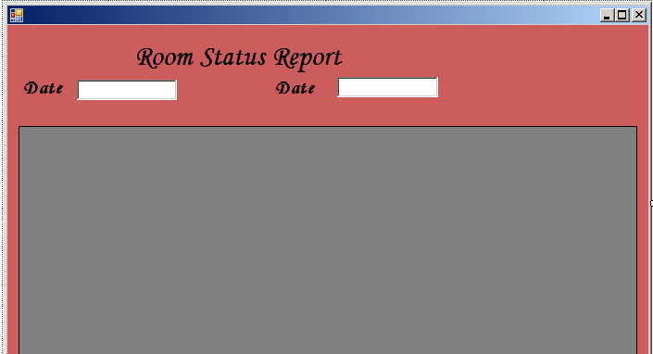

RoomStaus Form and Code

Imports System.Data.OleDb
Public Class Form11
Private Sub TextBox2_Leave(ByVal sender As Object, ByVal e As System.EventArgs) Handles TextBox2.Leave
Dim str As String
str = "Provider=Microsoft.JET.OLEDB.4.0;Data Source=D:\sunil\hotel1.mdb;"
Dim con As New OleDbConnection(str)
Dim str3 As String
con.Open()
str3 = "select * from rms where dat='" & TextBox1.Text & "' between dat='" & TextBox1.Text & "' and dat='" & TextBox2.Text & "'"
Dim cmd As New OleDbCommand(str3, con)
Dim adp As New OleDbDataAdapter(cmd)
Dim da As New DataSet
adp.Fill(da, "rms")
DataGridView1.DataSource = da.Tables(0)
con.Close()
End Sub
Table retrviewing data.

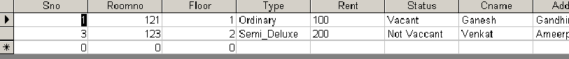

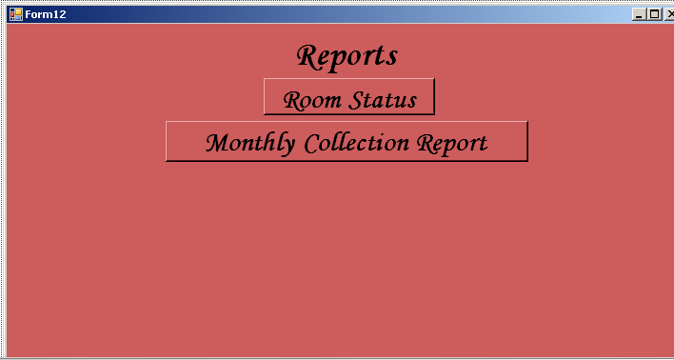
Reports Form and Code
Public Class Form12
Private Sub Button1_Click(ByVal sender As System.Object, ByVal e As System.EventArgs) Handles Button1.Click
Dim f11 As New Form11
f11.Show()
Me.Hide()
End Sub
Private Sub Button2_Click(ByVal sender As System.Object, ByVal e As System.EventArgs) Handles Button2.Click
Dim f13 As New Form13()
f13.Show()
End Sub
End Class

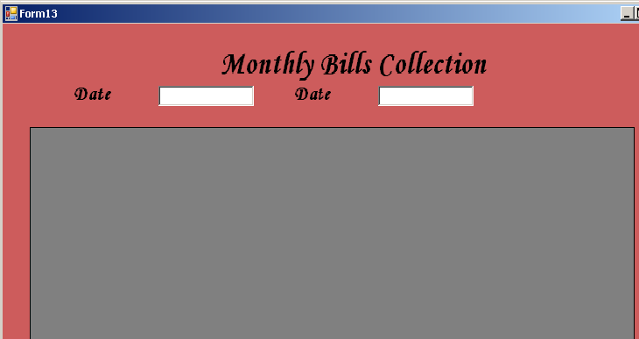
Monthly Bill Report Retrviewing from table
Total Bill’s Collection.
Code.
Imports System.Data.OleDb
Public Class Form13

Private Sub TextBox2_Leave(ByVal sender As Object, ByVal e As System.EventArgs) Handles TextBox2.Leave
Dim str As String
str = "Provider=Microsoft.JET.OLEDB.4.0;Data Source=D:\sunil\hotel1.mdb;"
Dim con As New OleDbConnection(str)
con.Open()
Dim sel As String
sel = "select * from Mcs where Cdt='" & TextBox1.Text & "' between Cdt='" & TextBox1.Text & "' and Cdt='" & TextBox2.Text & "'"
Dim com2 As New OleDbCommand(sel, con)
Dim adp As New OleDbDataAdapter(com2)
Dim ds As New DataSet
Dim dt As New DataTable
adp.Fill(ds, "Mcs")
dt = ds.Tables("Mcs")
DataGridView1.DataSource = ds.Tables(0)
con.Close()
End Sub
End Class

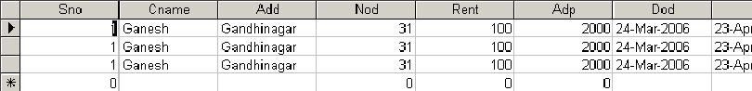
Totalbill table

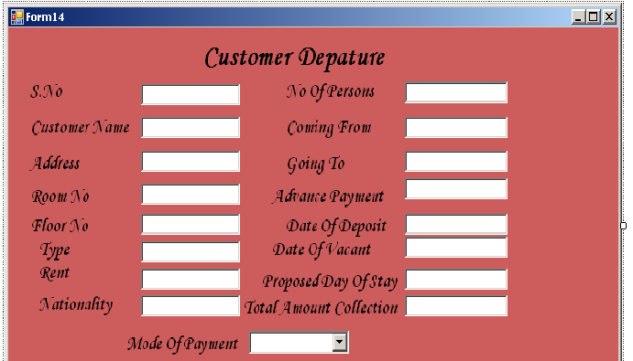
Customer Depature Form code and details.

Imports System.Data.OleDb
Public Class Form14

Private Sub TextBox1_Leave(ByVal sender As Object, ByVal e As System.EventArgs) Handles TextBox1.Leave
Dim str As String
str = "Provider=Microsoft.JET.OLEDB.4.0;Data Source=D:\sunil\hotel1.mdb;"
Dim con As New OleDbConnection(str)
con.Open()
Dim sel As String
sel = "select * from coll where Sno=" & Val(TextBox1.Text)
Dim cmd As New OleDbCommand(sel, con)
Dim adp As New OleDbDataAdapter(cmd)
Dim ds As New DataSet
Dim dt As New DataTable()
adp.Fill(ds, "coll")
dt = ds.Tables("coll")
TextBox2.Text = ds.Tables("coll").Rows(0).Item("Cname")
TextBox3.Text = ds.Tables("coll").Rows(0).Item("Add")
TextBox4.Text = ds.Tables("coll").Rows(0).Item("Rno")
TextBox5.Text = ds.Tables("coll").Rows(0).Item("Flr")
TextBox6.Text = ds.Tables("coll").Rows(0).Item("Type")
TextBox7.Text = ds.Tables("coll").Rows(0).Item("Rent")
TextBox8.Text = ds.Tables("coll").Rows(0).Item("Nat")
TextBox16.Text = ds.Tables("coll").Rows(0).Item("Nop")
TextBox15.Text = ds.Tables("coll").Rows(0).Item("Com")
TextBox14.Text = ds.Tables("coll").Rows(0).Item("Gon")
TextBox12.Text = ds.Tables("coll").Rows(0).Item("Adp")
TextBox11.Text = ds.Tables("coll").Rows(0).Item("Dod")
TextBox10.Text = ds.Tables("coll").Rows(0).Item("Dov")
TextBox13.Text = ds.Tables("coll").Rows(0).Item("Pnop")
TextBox9.Text = ds.Tables("coll").Rows(0).Item("Tamt")
con.Close()
End Sub

Private Sub ComboBox1_Leave(ByVal sender As Object, ByVal e As System.EventArgs) Handles ComboBox1.Leave
Dim str As String
str = "Provider=Microsoft.JET.OLEDB.4.0;Data Source=D:\sunil\hotel1.mdb;"
Dim con As New OleDbConnection(str)
con.Open()
Dim ins As String
ins = "insert into Mcs values("
ins = ins & Val(TextBox1.Text) & ",'"
ins = ins & TextBox2.Text & "','"
ins = ins & TextBox3.Text & "',"
ins = ins & Val(TextBox13.Text) & ","
ins = ins & Val(TextBox7.Text) & ","
ins = ins & Val(TextBox12.Text) & ",'"
ins = ins & TextBox11.Text & "','"
ins = ins & TextBox10.Text & "',"
ins = ins & Val(TextBox9.Text) & ",'"
ins = ins & ComboBox1.Text & "')"
Dim cmd As New OleDbCommand(ins, con)
cmd.ExecuteNonQuery()
con.Close()
MsgBox("Record Inserted")
End Sub
End Class

